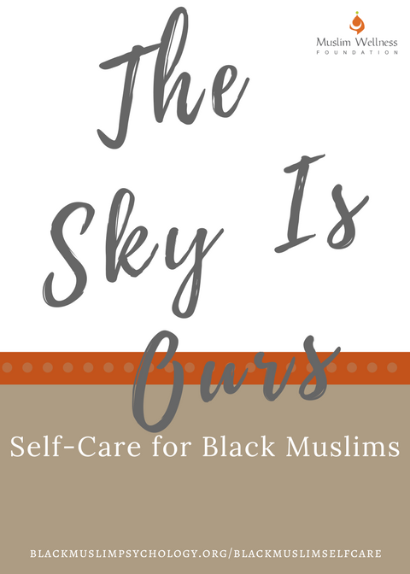
The Sky Is Ours: A Self-Care Primer for Black Muslims
By Kameelah Mu’Min Rashad, Founder – Muslim Wellness Foundation

Self-Care Tips & Strategies
Given the ongoing fight against police brutality and efforts to combat rising anti-Muslim bigotry, it is no surprise that many are experiencing some of the symptoms described above: from shock to outrage. Black Muslims must practice self-care and self-love with a renewed sense of urgency, determination and commitment. It is also important to note that the anniversary of the deaths of Sandra Bland (d. 7/13/15) and Eric Garner (7/17/14) are only a few short days away. This will be a difficult time of remembrance and mourning for many. Having a self-care plan ready can help provide ease during this challenging time. Here are a few practical tips for those that are looking for strategies to cope with the horror, shock and fear trigged by recent events, specifically the deaths of Alton Sterling and Philando Castile.

Take A Break From Social Media

Seriously. This is often difficult for many of us to do. We want to stay informed and plugged into all of the breaking news. Yet we consume an overwhelming amount of harmful images and negative stereotypes and this consumption can be extremely disheartening and toxic. If your work or advocacy requires that you follow trending topics, at the very least, set limits around how much time you devote to being online. For example, turn your phone off and do not check social media until one hour after waking in the morning and log off one hour before going to bed. Lastly, do NOT engage in online debates or feel the need to respond to every offensive comment, tweet or snap. The world will continue to spin on its axis if you decide NOT to reply to the racist comment posted by a friend of a friend of your high school acquaintance.

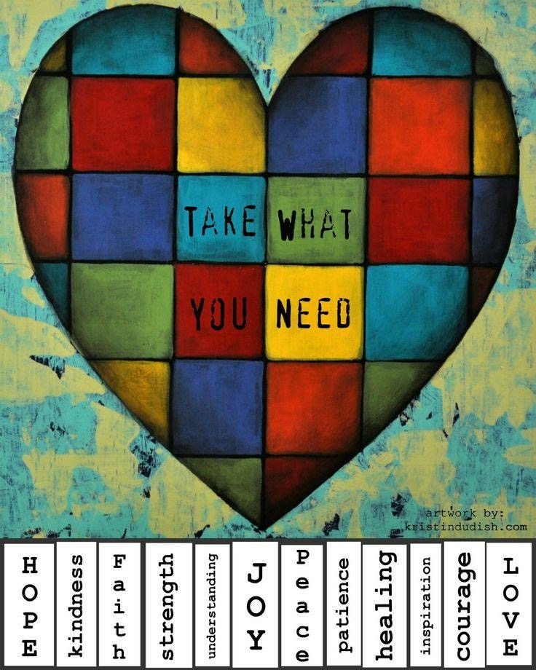
Stay Connected
One of the symptoms of trauma and grief is the tendency to withdraw and isolate from others. Instead, reach out to those you trust and share your pain. Chances are, your loved ones are struggling in similar ways.
Be vulnerable.
Seek comfort from those that “get it”.
Ask for a hug.
Say “this hurts and I’m overwhelmed”.

Have Fun (Laugh)!
It is easy to sink into despair and hopelessness thinking about all of the hate, violence and chaos in the world. We are all trying to cope in this challenging times but we must also bear in mind that staying connected to all that brings us joy and happiness provides hope. The hashtag #CareFreeBlackKids2k16 was created with this idea in mind - as a reminder that joy and laughter are often our best antidote to despair.
Suggestions:
Play a board game like scrabble
Jump rope
Buy a coloring book and crayons
Have a dance party
Sing out loud!
Blow bubbles

Prayer, Supplication & Meditation
The wisdom and value of salat (prayer) and duaa (supplication) cannot be overstated. It is understandably hard to concentrate when the world feels as if it’s heading a break neck speed towards some prophesized doom. Yet, this is EXACTLY the time when turning to Allah (swt) will provide comfort and ease. In fact, it is reported that Prophet Muhammad (saw) said: Beware the duaa of the oppressed, for nothing stands between it and Allah.
- Develop a ritual around each prayer time – if you can, give yourself a few minutes to sit, contemplate and reflect before rushing back into the regular routine of the day. This 5-10 minutes can help bring back clarity and focus.

- Make a list of your favorite verses from the Qu’ran or hadith that resonate with you and offer reassurance. Here are a few examples:
- The Prophet (saw) said: “No fatigue, nor disease, nor sorrow, nor sadness, nor hurt, nor distress befalls a Muslim, even if it were the prick he receives from a thorn, but that Allah expiates some of his sins for that.” [Sahih Bukhari]
- “And We will surely test you with something of fear and hunger and a loss of wealth and lives and fruits, but give good tidings to the patient. Who, when disaster strikes them, say, "Indeed we belong to Allah, and indeed to Him we will return.” Those are the ones upon whom are blessings from their Lord and mercy. And it is those who are the [rightly] guided. Qu’ran (2: 155-157)
The Prophet Muhammad (saw) would make this duaa often: O Allah, I take refuge in You from anxiety and sorrow, weakness and laziness, miserliness and cowardice, the burden of debts and from being overpowered by men {Allahumma inni a'udhu bika minal-hammi wal-Ḥuzni wal-'ajazi wal-kasli wal-bukhli wal-jubni wa ḍalaEid-dayni wa ghalabatir-rijal}.
- “And We send down of the Quran that which is a healing and a mercy to those who believe (Qu’ran 17:82).
- Download a Quran app. Listening to the soothing words of our Holy Book can be the perfect medicine in times of distress.
Download a mindfulness or meditation app on your phone. Apps like Headspace, Buddhify and Stop, Breathe, Think offer an easy way of tracking your emotions and steps towards guided breathing, meditation and silent reflection. For some suggestions, take a look at the reviews found here and here.

Get Active!
It is an undeniable fact that physical activity reduces stress. According to the Anxiety and Depression Association of America, exercise and other physical activity produce endorphins—chemicals in the brain that act as natural painkillers—and also improve the ability to sleep, which in turn reduces stress. Even FIVE MINUTES of activity can noticeably reduce anxiety levels. Psychologists studying how exercise relieves anxiety and depression suggest that a 10-minute walk may be just as good as a 45-minute workout. Some studies show that exercise can work quickly to elevate depressed mood in many people. Although the effects may be temporary, they demonstrate that a brisk walk or other simple activity can deliver several hours of relief, similar to taking an aspirin for a headache. Now I’m not suggesting that you begin training for a marathon! But moving your body in some way can improve your mood. Here are some tips:
- March in place (high-knees) for five (5) minutes
- Do 10-15 jumping jacks
- Go for a brisk 10 minute walk (raise your heart rate).
- More suggestions here

- Don’t forget to pay attention to diet: What we eat and drink largely impacts our emotional state. Foods most associated with exacerbating anxiety are ones containing caffeine and alcohol. Even consumed in small amounts, studies have found that the stimulating effects of caffeine can cause anxiety, trigger panic attacks, and increase feelings of nervousness and irritability

Pamper Yourself!
Most people assume that self-care must take the form of a day at the spa, or spending money on a pedicure or manicure. While a luxurious facial and massage can make a WORLD of difference, there are many other no-cost options available as well.
- Drink a cup of (de-caffeinated) herbal tea
- Take a hot bath or shower
- Burn a scented candle and breath in the aroma
Indulge yourself! Eat a piece of dark chocolate
- Find more suggestions here

Find A Therapist

Let’s make one thing clear: seeking help is NOT a sign of weakness or ingratitude for the blessings Allah has bestowed upon us. For those experiencing anxiety, depression or simply being overwhelmed by life stressors, stigma acts as a significant barrier to seeking the help that is needed. In the American Muslim community, mental health challenges are just as prevalent as in other communities, yet stigma stemming from cultural and religious beliefs many Muslims to feel that they must suffer in silence. American Muslims struggling with mental illness or addiction may attribute their experience to weak faith, a punishment from God or test of perseverance and fortitude. Other barriers also exist that make seeking help incredibly difficult, including discrimination, racism, Islamophobia and lack of mental health professionals with a basic knowledge of Islam and Muslims.
The Ladipo Group is an African American owned therapy practice in Philadelphia and explains why counseling can be so beneficial:
With all of the struggles and oppressions that we face on a daily basis we need an outlet. We need a comfortable environment where we can talk about the impact oppression has on us and talk about healthy and productive ways to deal with it. Holding in the pain, frustration, anger, and sadness eats at you, leaving you feeling angry and dissatisfied, not a rewarding way to go through life.When you find an effective therapist, therapy can be a place to gain support and find more satisfying ways to live life. It is the one place, perhaps the only place, where you don’t have to have all of the answers and you don’t have to worry about the person sitting across from you. It is a place where you only have to worry about yourself and your needs

While it is true that finding a competent and qualified counselor/therapist/psychologist/psychiatrist may take some time, for our long term health and well-being, we MUST begin to bravely address our individual and collective “baggage”. The secrets, silence, shame surrounding our emotional and psychological health only deepen the pain and isolation. Take a moment to understand how therapy works (click here for a helpful link). Engaging in therapy is the ultimate act of self-care and self-love.

Create Your Own Self-Care Plan
Use the following resources to develop your own person self-care plan. Click on each image below to download the worksheet.

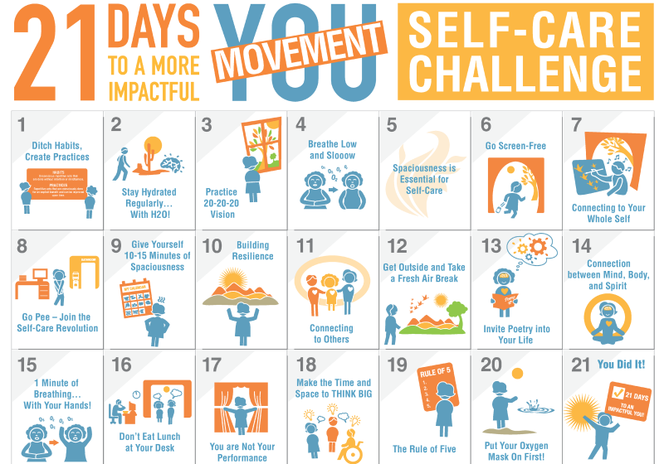
21 Day Self-Care Challenge
Self-Care Wheel
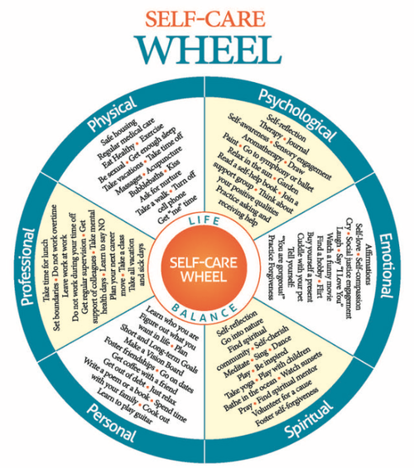
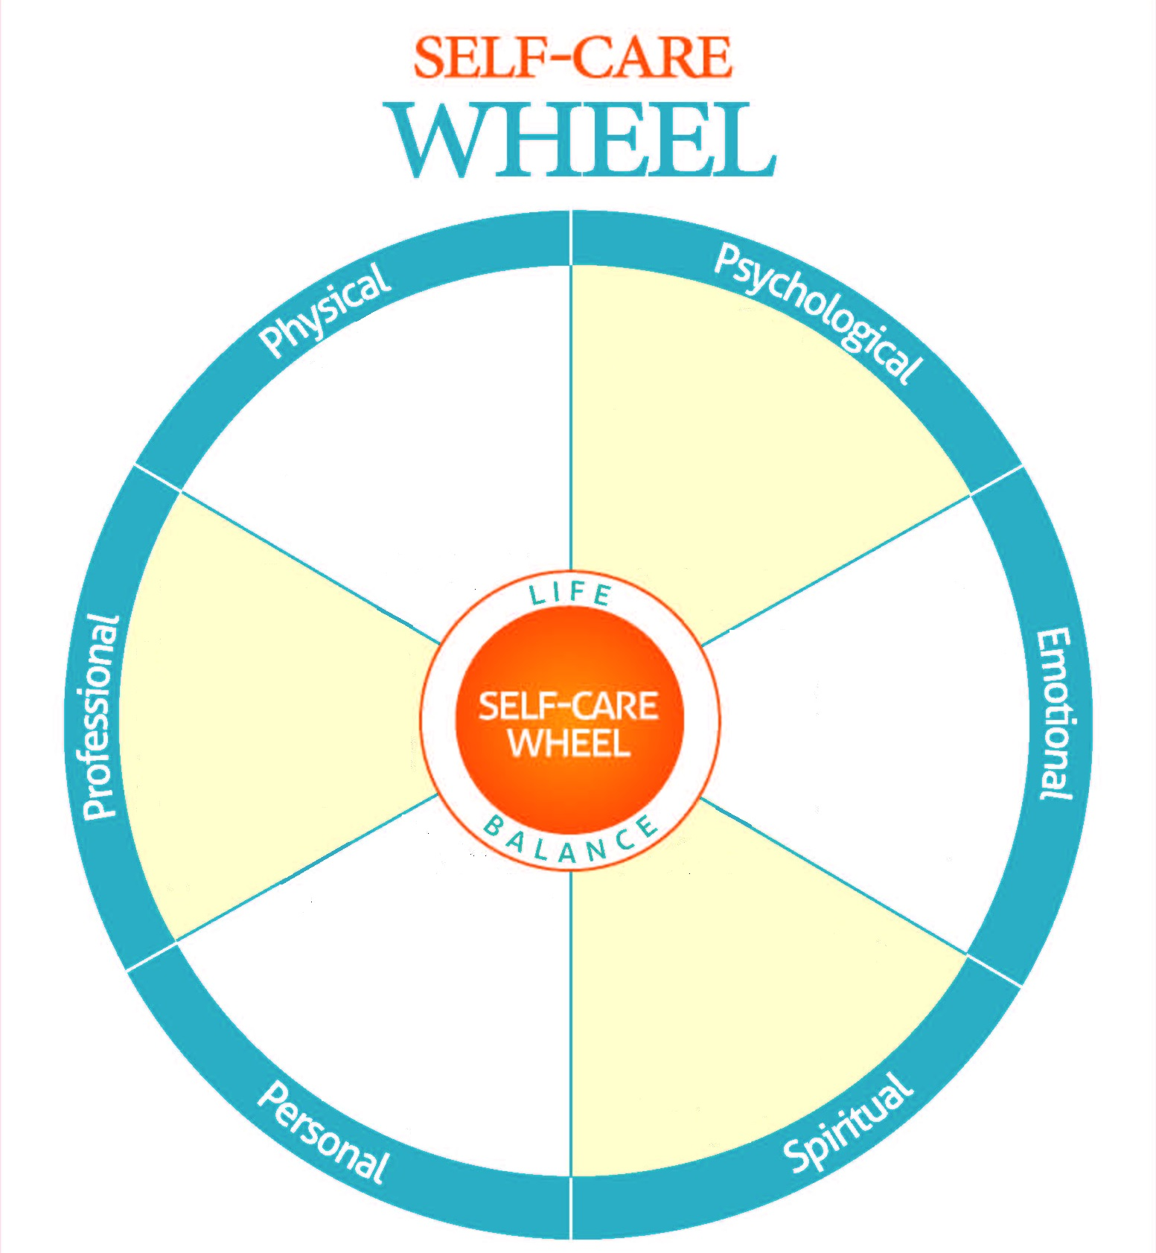
Blank Self-Care Wheel
More Helpful Tips:
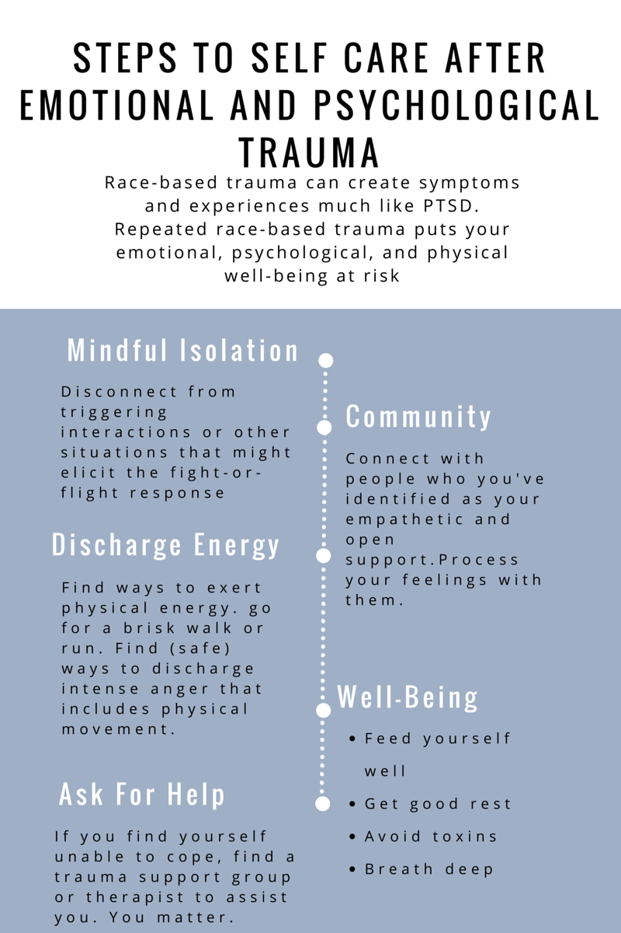

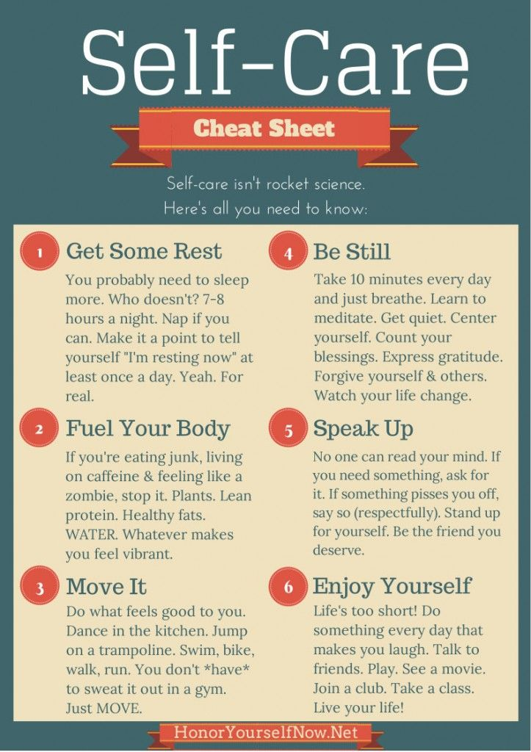
MENTAL HEALTH RESOURCES

Healthy Minds: Online Mental Health Screening
You keep tabs on your blood pressure, weight, and cholesterol. How about your emotional well-being? You can check it out right here, anytime. This tool is completely anonymous. In a few minutes, you will learn whether or not you might be experiencing behavioral health challenges.

The Holmes and Rahe Stress Scale
Stress is a condition or feeling experienced when a person perceives that "demands exceed the personal and social resources the individual is able to mobilize." In less formal terms, we feel stressed when we feel that "things are out of control". The Holmes and Rahe Stress Scale is a tool helps us measure the stress load we carry, and think about what we should do about it.

National Suicide Prevention Lifeline
If you feel you are in a crisis, whether or not you are thinking about killing yourself, please call the Lifeline. People have called us for help with substance abuse, economic worries, relationship and family problems, sexual orientation, illness, getting over abuse, depression, mental and physical illness, and even loneliness.

Khalil Center
Khalil Center is a community psychological and spiritual wellness center. Khalil Center’s approach emphasizes: psychological reconstruction, behavioral reformation and spiritual elevation. Khalil Center utilizes faith-based approaches rooted in Islamic theological concepts while integrating the science of psychology towards addressing social, psychological, communal and spiritual health

Muslim Mental Health - Find A Therapist
This directory is a very useful tool to help people find a counselor, therapist, psychologist, and/or psychiatrist throughout North America

Muslim Wellness Foundation
Muslim Wellness Foundation (MWF) is an organization which seeks to reduce stigma associate with mental illness, addiction and trauma through dialogue, education and training.

Nasiha Counseling
Counseling can be a meaningful way to address some of life's challenges you are facing or have been facing for a long time. As therapists, we provide support and feedback to help you cope with current life challenges and long-standing issues

HELPFUL LINKS & ARTICLES:

5 Self-Care Practices Black People Can Use While Coping With Trauma

Footage of Police Killings Has Enabled A Sick Sort of Voyeurism

OpEd: A Spiral of Anger and Helplessness, My Search For Self-Care

How Black People Can Emotionally Protect Themselves in the Age of #BlackLivesMatter

We Can Help Each Other Cope: One Simple Way to Be With Each Other Through Pain Right Now

These Days, Black Self Care Matters Too

4 Self-Care Resources for Days When the World is Terrible

Tips for Self-Care: When Police Brutality Has You Questioning Humanity and Social Media Is Enough

Racism’s Psychological Toll

Emotional and Psychological Trauma

Emotional and Psychological Trauma: Causes and Effects, Symptoms and Treatment

The Ripple Effects of Police Violence

The Supplication Series: Distress, Sadness and Anxiety

Exercise and Stress: Get Moving To Manage Stress

The Mental Health Benefits of Exercise

23 Science- Backed Ways To Reduce Stress Right Now

The Best 7 Anti-Anxiety Foods

Dark Chocolate Takes A Bite Out Of Stress

DEVELOPING A SELF-CARE PLAN

Self-Care Wheel

21 Day Self-Care Challenge

Social Work & Self-Care

ABOUT MUSLIM WELLNESS FOUNDATION (MWF)
Muslim Wellness Foundation (MWF) is a 501(c)(3) nonprofit organization dedicated to reducing stigma associated with mental illness, addiction and trauma in the American Muslim community through dialogue, education and training. We envision a future in which faith communities are at the forefront of mental health advocacy and committed to developing an inclusive culture of compassion, understanding and support.
For those experiencing a mental health challenge, stigma acts as a significant barrier to seeking the help that is needed. In the American Muslim community, mental health challenges are just as prevalent as in other communities, yet stigma stemming from cultural and religious beliefs lead many to feel that they must suffer in silence. American Muslims struggling with mental illness or addiction may attribute their experience to weak faith, a punishment from God or test of perseverance and fortitude. Our aim is to address the glaring mental health disparities present in the American Muslim community by engaging community members, health professionals, and religious leaders in conversation to improve mental health literacy, stigma reduction, help-seeking behavior and access to affordable and culturally competent services. In order to achieve this goal, we have adopted an interdisciplinary, spiritually grounded, community based public health approach to wellness. This approach emphasizes the importance of addressing sociocultural stressors (poverty, oppression, anti-Black racism) that lead to diminished well being. Racial oppression and religious discrimination are also forms of violence, which inevitably lead to trauma and stress. Therefore, we advocate that health is not simply the absence of illness, but draws upon a holistic understanding of an individual’s environment and leverages community, faith and identity in the attainment of an optimal quality of life.

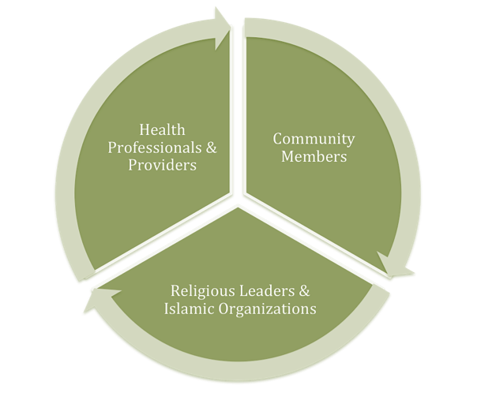
Muslim Wellness Model
In order to achieve this goal, we have adopted an interdisciplinary approach which promotes emotional well-being using a holistic, spiritually relevant, community-based public health framework. We engage community members, health professionals and providers & religious leaders and Islamic organizations in much needed dialogue and conversation. Our projects and initiatives focus on 3 major areas:
  - Community Engagement & Outreach
  - Training & Consultation
  - Professional Development & Networking
MWF is leading the way in Muslim mental health awareness by offering community based workshops and seminars. A few of our key initiatives include Mental Health First Aid training, Annual Black Muslim Psychology Conference (BMPC), Youth Anti-Muslim Bigotry Symposium, Healers Collective Forum (online resource for Muslim mental health professionals) and several community based workshops including a maternal mental health retreat for Muslim women, stepfamily workshop, online webinars on topics such as sexual abuse, domestic violence/spiritual abuse, coping with racism, developing a national network of Muslim mental health professionals.

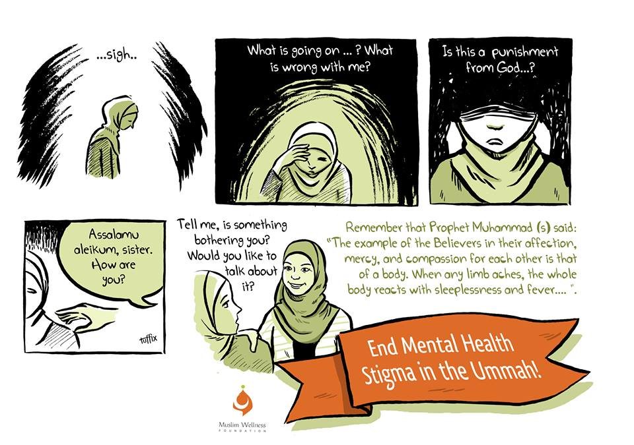
CONTACT:
Muslim Wellness Foundation
7433 Limekiln Pike
Suite 204
Philadelphia, PA 19138
info@muslimwellness.com
Tel: (267) 571-1730

KAMEELAH MU’MIN RASHAD, MS, MRP, M.ED
Founder & President, Muslim Wellness Foundation
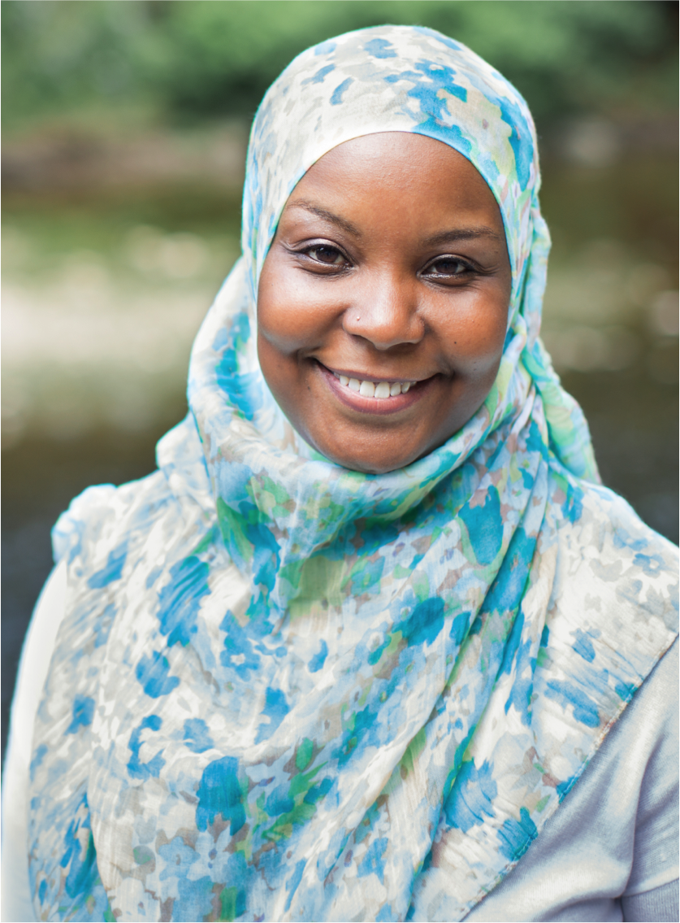
Kameelah is the Founder and President of Muslim Wellness Foundation (MWF), a nonprofit organization dedicated to reducing stigma associated with mental illness, addiction and trauma in the American Muslim community through dialogue, education and training. Muslim Wellness Foundation envisions a future in which faith communities are at the forefront of mental health advocacy and committed to developing an inclusive culture of compassion, understanding and holistic health.
Kameelah also serves as the Fellow for Spirituality, Wellness and Social Justice at the University of Pennsylvania (UPenn) and advisor for Penn Sapelo, the first Black Muslim Student organization on campus. In this capacity, Kameelah supports students in their exploration of faith-based activism, spirituality, emotional well-being and healing. Working in conjunction with the Chaplain’s Office, she collaborates with other cultural centers on campus to facilitate intersectional conversations on race, religion, identity, belonging and advocacy. Kameelah served three years as the Muslim Chaplain at UPenn and continues to facilitate discussions on religious identity development and challenges faced by American Muslim youth. She is also a resource to the wider Penn community and administration on Islam and Muslims.
In addition to Kameelah’s involvement in mental health advocacy and religious life, she is a proud social justice activist and founding member of Muslims Make It Plain, a coalition of concerned Muslims working to inspire, empower and support grass roots mobilization and direct action to address police brutality, racial & religious profiling, unlawful surveillance and the overpolicing of America’s Black & Brown communities. In December 2014, Muslims Make It Plain organized the first Muslim led rally and march in the country in support of BlackLivesMatter. Kameelah serves as a member of the Advisory Council of Muslim Advocates, a national legal advocacy and educational organization that works on the frontlines of civil rights to guarantee freedom and justice for Americans of all faiths. Further, Kameelah is an advisory board member of Muslim Anti-Racism Collaborative (MuslimARC), Stony Point Center, Social Health & Medical Services (SHAMS) Clinic and the Husayn Center for Social Justice, a Muslim-run social services and advocacy center that promotes health and wellness for the residents of Trenton, NJ.
Kameelah is a 2014 Ariane deRothschild Fellow and a recipient of the 2014 Student Multiculturalism and Salter Family Memorial Education Awards and recipient of the 2017 Matthew Smith Education Award from the Pennsylvania Psychological Association (PPA). Since 2015 Kameelah has served as the Diversity Focus Chair for PPA's Graduate Student Board. National Council for Behavioral Health selected Kameelah for the prestigious 2015 Mental Health First Aid (MHFA) Community Impact Award and honored her as a "passionate, committed, and outstanding behavioral health leader".
In February of 2015, Kameelah was one of 14 American Muslim Leaders invited to attend a Roundtable discussion with President Obama at the White House. At that meeting, Kameelah shared her concerns regarding the psychological impact of anti-Muslim bigotry on the Muslim community, particularly as it effects youth and African Americans. Kameelah has since been invited to a subsequent roundtable discussion with President Obama before his historic visit to a U.S. Mosque in Feb 2016 and listening sessions with senior White House officials on mental health in the American Muslim community. Kameelah’s insights and perspectives have been featured in The Huffington Post, The Atlantic, BuzzFeed, Patheos-Muslim, MuslimMatters, The Pennsylvania Gazette, and NPR’s Radio Times with Marty Moss-Coane
Kameelah graduated from the University of Pennsylvania with a BA in Psychology and MEd in Psychological Services. She has pursued further graduate education, completing a second Masters in Restorative Practices & Youth Counseling (MRP) from the International Institute for Restorative Practices and obtaining a post-Masters certificate in Family Therapy from the Philadelphia Child & Family Therapy Training Center. Kameelah is a certified instructor in Adult, Higher Education & Youth Mental Health First Aid. She is pursuing her doctorate in Clinical Psychology at Chestnut Hill College in Philadelphia, PA.

